Gathering some rod balancing data

Note on group work
In this course you will work with your group to produce, analyze and present data. Take a moment of this session to get to know the rest of your group.

The experiment
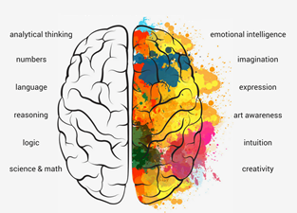
A widespread idea in popular science is that the two hemispheres of the brain have different functions. The left hemisphere is specialized to control movement and process sense data from the right side of the body and visa versa. There is also some support for specialization of language in the left hemisphere. The extent to which these functions, language and motor control, interfere with each other can be used as a measure of how much their representation in the brain overlaps. In this session we will replicate a classic demonstration of this idea.
Take the experiment seriously to collect and record data as accurately as you can, but also have fun. You are not obliged to take part in the experiment, and you should not put pressure on others to take part.

Procedure
Divide your group into subgroups of three people each with a rod, a stopwatch (e.g. on a phone or watch) and a recording sheet. Take turns to act as a participant, an observer and a scribe.
One each trial the:
- Participant balances the rod on their fingertip while standing. On speaking conditions choose a phrase to repeat or hold a conversation with one of your group.
- The observer watches the participant, starts and stops the timer and calls out the result.
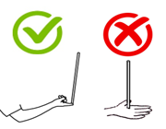
- The scribe records the results and dictates the order of conditions according to the excel sheet. Conditions are coded by number:

1 | Right hand, silent
2 | Right hand, speaking
3 | Left hand, silent
4 | Left hand, speaking

- Each condition should be repeated 6 times

At the end of the session combine the group data into one excel sheet and upload your results CANVAS

